**Follow up on Fogarty et al (2001) paper**

**Introduction**

Recruitment variability among marine fish species is known to be quite variable and can depend on a variety of both intrinsic and extrinsic factors. Intrinsic factors such as the biomass and physiological condition of the spawning stock plays a dominant role in determining recruitment success for many species, primarily those that are long-lived, iteroparous and attain large body sizes. Age and size structure and the diversity of age structure also play important roles in recruitment success given the demonstrated survival advantage offspring from older, repeat spawners have over first time, smaller parents. Extrinsic factors involving environmental variability can influence recruitment success, more commonly among small bodied, semelparous, short lived species but can become more influential among larger-bodied species when exploitation effects cause a truncation of age structure and/or a reduction in stock biomass or body size. The relationship between environmental variability and recruitment not only changes over life history stages but the nature and strength can change over time (Myers 1998; Brosset et al. 2020)

Defining a set of species traits that influence its characteristic recruitment variability has been undertaken in the past by many researchers. Among species, the magnitude of recruitment variability is associated with life history strategies (Winemiller and Rose 1992; is generally higher in small, fast-growing pelagic species whereas low-variability stocks than in large-bodied slow-growing, demersal species (Spencer and Collie 1997; Petrik et al. 2021). The source of variability can originate through largely density-dependent processes from egg, larval and juvenile to adult life stages, and the interactions among stages (Houde 2008).

Some of the most perplexing patterns exist when seemingly closely related, sympatric species exhibit differential recruitment success . Cod and haddock are gadoids found in shelf ecosystems in the western and eastern North Atlantic. The species have similar habitat requirements and overlaps geographically, although cod extends further north and into colder waters on both sides of the Atlantic (ref). Cod and haddock sustained large fisheries, often targeting both species in areas where they co-occur. Most stocks of these species have been overexploited historically. By the early 1990, the cod and haddock fishery in the North West Atlantic had collapsed, with landings of cod and haddock less than 10% of historic maxima (Figure ?).

The declines of cod and haddock stocks motivated Fogarty et al (2001) to study the two species’ resilience to over-exploitation and their capacity for recovery from depletion. Their study was conducted using stock recruit models on assessment outputs updated to the mid 1990’s. The paper compared sympatric cod and haddock stocks with respect to rate of recruitment at low SSB levels (“steepness” e.g. Thorson 2018), and recruitment variability. They found that haddock stocks had a consistently higher variability and lower steepness compared to cod stocks in the same area. This led the authors to propose that cod have a higher resilience to overexploitation, but that depleted haddock stocks might be rescued by chance recruitments events and recover if strong year classes were protected from (over) exploitation.

Since Fogarty et al. 2001, the shelf ecosystems in the Northern Atlantic have changed considerably. These changes are likely to influence the reproductive success as well as recruitment variability of the stocks (Mantzouni et al 2009, Houde et al 2016). In the western Atlantic, fishing moratoria were introduced following the stock collapses, the stock collapses were accompanied by ecosystem regime shifts, and trophic cascades delaying and preventing stock recovery (Frank et al 2005) and altering food availability and the abundance of competitors and/or predators of pre-recruit cod and haddock, which in turn is impacting recruitment (e.g. predator -prey role reversals, ref).

In the eastern Atlantic, the northernmost stocks, found in the Barents Sea, have increased reaching record high SSBs, after fishing pressure was reduced. As the stock sizes increased, they have expanded north (Johannesen et al 2021, Landa et al 2014). Stock size and spatial distribution influence spawning site selection (Langangen et al 2019, Stige et al 2018) and thus potentially reproductive success.

Furthermore, demographic structure of many cod and haddock stocks has changed. For instance, condition and size at age of cod and haddock at Scotian shelf has declined since the mid 1990’s and remained low since then (Shackell and Frank 2007, Shackell et al 2010). In North Sea cod and haddock size and maturity at age has declined (Baudron et al 2011, 2014, Marty et al 2014), and similar but not as dramatic declines in size and maturity of age have been observed for Icelandic cod (e.g. Pardoe et al 2009).

All of these species-specific fishing induced changes have largely occurred prior to or during a much larger-scale environmental change. Global warming trends have occurred in the shelf seas in the north Atlantic, with accelerated warming in the most recent decades (Garcia-Soto et al 2021). These well documented changes in the ecosystems, management regimes, and stock characteristics (spatial distributions, maturity, size and conditions at age), occurring in a warming ocean, all are likely to impact recruitment variability and success for both cod and haddock, but not necessarily to the same extend or in the same direction throughout their range (Mantzouni et al 2009).

We analyse updated stock assessment output and test if the higher recruitment variability and lower steepness of haddock compared to cod found in Fogarty et al (2001) is constant over time by splitting the analysis into two periods – before 1993 and recent. The division corresponds to stock collapses and ecosystem changes in the North west Atlantic and approximately correspond to when the data used in Fogarty et al paper data ended. We then characterize patterns of recruitment variability with respect to species and period.

**Methods**

**Data**

We compiled time series of recruitment (R) and spawning stock biomass (SSB) of sympatric cod and haddock stocks from the most recent available assessments conducted by the International Exploration of the Seas (ICES), Department of Fisheries and Oceans Canada (DFO) and the National Marine Fisheries Service (NMFS). These stock pairs were from the same geographic areas that were evaluated by Fogarty et al (2001); we also added one additional area - the Irish Sea (Table 1). The West of Scotland region which was part of the original analysis by Fogarty et al. (2001) was excluded from our analysis, since haddock West of Scotland is no longer assessed as a separate stock, but instead is now assessed as part of the larger North Sea stock. We considered pooling cod West of Scotland with North Sea cod to make cod and haddock more comparable for the region, but since the cod West of Scotland time series is considerably shorter and the recruits from this stock is on average only 2% of the North Sea stock, we decided to keep the North Sea cod series as it was, and not consider West of Scotland further.HIGHLIGHTED EXPLANATION NO NECESSARY

The 2021 ICES advice web site (https://www.ices.dk/advice/Pages/Latest-Advice.aspx), were used to access recruitment and SSB data for the North East Atlantic stocks except for the Faroese stock (2020 advice) and Irish Sea (cod: 2014, haddock 2020).

The North West Atlantic recruitment and spawning biomass data was taken from … The Scotian shelf had older assessments going back further in time that also were available (Table 1). These are not directly compatible with to the newest assessments and since we are primarily interested in what has happened since the Fogarty et al (2001) paper, we considered only the most updated data sets in our analysis. It is noteworthy that some of the stock in particular on the Western Atlantic side, are no longer regularly assessed, e.g. the Eastern Scotian Shelf haddock, previously an important stock, has not been assessed since 2000 (Table 1)

We are primarily interested in the difference between cod and haddock within regions, less so in the differences between regions (Table 1). The age at recruitment differs among regions and in some cases, age at recruitment differs within species within regions. Fogarty et al (2001) standardised recruitment of all stocks to age 1. Here we adopted a conservative approach and only standardised the stocks within regions, when age at recruitment differed. The number at age 1 from the assessment (ICES 2021) was used for recruitment for North Sea haddock. The estimate takes into account natural mortality and fishing mortality due to discards. The assessment reports for the Irish Sea haddock (ICES 2019) and the Icelandic stocks did not include numbers at age estimate for relevant ages, but provided a Table with F’s from age 0-5, allowing us to calculate age 1 recruitment (R1) assuming M=0.2. We calculated age 2 recruitment (R2) for Icelandic cod assuming M=0.2 and F=0.-

**Analysis**

To assess the recruitment variability, we followed Fogarty et al (2001) by first fitting a Ricker model to all stocks (Appendix Figure 1 and 2).

The Ricker model was linearized to:

Eq 1:

$$\log\left(\frac{R}{SSB}\right)=\log\left(a\right)+b×log\left(SSb\right)+ ε\text{i}$$

Recruitment variability was then assessed by calculating the standard deviations of the residuals from the Ricker model. Since the Ricker model constrains the relationship between SSB and recruitment in a manner that often fit the data poorly, we also used an alternate, model-free approach using Generalized Additive Models (GAMS). We accounted for SSB by detrending the log10 transformed R using GAM smoothing for each stock (Appendix Figure 3) and calculated the standard deviation of the residuals from the fit. In both approaches, we treated the time series of residual variability before and after 1993. This was done for two reasons: many of time series for the stock pairs evaluated by Fogarty et al. (2001) ended in the early 1990s or sooner and the early 1990s marked a point in time when many of the NW Atlantic stocks of cod and haddock either collapsed or reached a historical minimum.

The standard deviation of the residuals for cod vs haddock was then plotted for each region (n=8).

The steepness (e.g. Thorson 2019, Lowerre-Barbieri et al 2017), that is the number of recruits produced per unit SSB at low SSB levels, is indicative of the stocks ability to recover from collapse/depletion. Steepness can be derived from **a** in Eq 1 above, or calculating the average R/SSB at low SSB levels and in our analyses we chose a threshold of 20% of the maximum SSB value. Here we used both approaches, and plotted the steepnessestimates of cod vs haddock for each region (n=8 *).*

We also quantified temporal autocorrelation in the recruitment residuals from both the Ricker and GAM models. Significant negative autocorrelation implies inter-cohort intraspecific competition and/or cannibalism, whereas positive autocorrelation may indicate environmental forcing acting in the same direction over consecutive years (Ricard et al 2016). This analysis was conducted in order to determine if there were species-specific patterns that might help to explain difference is the magnitude of residual variability between the two species.

Finally, we estimated the temporal correlation of recruitment residuals between cod and haddock stocks within each region. A positive correlation may imply that the two species are responding to environmental drivers in the same way, a negative correlation might imply interspecific competition, predation or that environmental drivers have an opposite effect on the two species (ref). The correlation between recruitment of sympatric stocks may also change over time (e.g. Bogstad et al 2013 for Barents Sea cod and haddock). We evaluated this possibility through a sliding window approach, using a 15 year time block to assess the correlation between species (see data file).

Table 1 Region, ecosystem, latitude, area in km2, temperature, species (C=cod, H=haddock), age at recruitment used in the assessment, standard deviation of the log10 transformed recruitment indices, start and end year of time series, minimum and maximum spawning stock biomass in kilotons, with associated year in parenthesis and ratio of average SSB prior to 1993 and 1993 and thereafter.

|  |  |  |  |  |  |  |  |  |  |  |  |
| --- | --- | --- | --- | --- | --- | --- | --- | --- | --- | --- | --- |
|  | Region | lat | Km2 | tempr | Species | R age | Std  log10rec | years | minssb | Max ssb | Before  /after |
| NEA | Barents Sea |  |  |  | C | 3 | 0.323 | 1946-2018 | 108 (1965) | 2263 (2013) | 2.9 |
|  |  |  |  |  | H | 3 | 0.505 | 1950-2018 | 49 (1985) | 524 (2013) | 1.88 |
|  | Faroese |  |  |  | C | 1 | 0.332 | 1959-2019 | 15 (2007) | 122 (1984) | 0.53 |
|  |  |  |  |  | H | 1 | 0.485 | 1957-2019 | 10 (2011) | 94 (2003) | 0.77 |
|  | Icelandic |  |  |  | C | 3 | 0.146 | 1955-2018 | 115 (1993) | 726 (1955) | 0.81 |
|  |  |  |  |  | H | 2 | 0.348 | 1979-2019 | 35 (1987) | 154 (2004) | 1.22 |
|  | Irish Sea |  |  |  | C | 1 | 0.408 | 1968-2012 | 1 (2009) | 19 (1982) | 0.25 |
|  |  |  |  |  | H | 0 | 0.332 | 1993-2019 | 2 (1994) | 21 (2018) |  |
|  | North Sea |  |  |  | C | 1 | 0.378 | 1963-2020 | 32 (2005) | 220 (1971) | 0.49 |
|  |  |  |  |  | H | 0 | 0.613 | 1972-2021 | 52 (1991) | 551 (2002) | 1.11 |
|  | North Sea + W. of Scot. |  |  |  | C | 1 | 0.349 | 1981-2020* | 35 (2005) | 172 (1982) | 0.62 |
|  | West of Scotland |  |  |  | C | 1 | 0.392 | 1981-2020* | 2 (2006) | 43 (1981) | 0.22 |
| NWA | Eastern Georges Bank |  |  |  | C | 1 | 0.416 | 1978-2014 | 6 (2005) | 60 (1981) | 0.3 |
|  |  |  |  |  | H | 1 | 0.658 | 1969-2014 | 5 (1974) | 126 (2014) | 2.92 |
|  | Eastern Scotian Shelf |  |  |  | C | 1 | 0.336 | 1970-2009 | 4 (2003) | 156 (1985) | 0.13 |
|  |  |  |  |  | H | 1 | 0.405 | 1970-2000 | 7 (1974) | 84 (1985) | 0.5 |
|  |  |  |  |  | C | 1 | 0.225 | 1958-1996* | 12 (1994) | 217 (1985) | 0.12 |
|  |  |  |  |  | H | 1 | 0.405 | 1948-1981* | 4 (1974) | 97 (1953) |  |
|  | Western Scotian Shelf |  |  |  | C | 1 | 0.372 | 1983-2016 | 6 (2013) | 104 (1991) | 0.44 |
|  |  |  |  |  | H | 1 | 0.373 | 1985-2013 | 16 (2013) | 49 (2004) | 1.1 |
|  |  |  |  |  | C | 1 | 0.28 | 1980-2007* | 15 (2007) | 88 (1981) | 0.42 |
|  |  |  |  |  | H | 1 | 0.342 | 1962-1998* | 18 (1990) | 100 (1967) | 0.55 |

*not used further

**Results.**

Overall, there has been a decline in recruitment in all of the cod stocks except the Iceland and Barents Sea stocks. The same pattern is not as evident for the haddock stocks, and a larger variability in haddock recruitment compared to sympatric cod can be seen from recruitment plots directly (Figure 1; see also Table 1).

Recruitment residuals from the Ricker (Figure 2a) and GAM models (Figure 2b) illustrates a larger recruitment variability in haddock compared to cod. Noteworthy is also a decline in the recruitment variability for the Barents Sea stocks (Figure 2), coinciding with an increase in the spawning stocks (Table 1).

The autocorrelation in the residuals by period is shown as Figure 3. and the correlogram at different lags are found in the appendix as figure 4. The autocorrelation was mostly positive, except for the Eastern Georges Bank Cod and for the Ricker model for Irish Sea Haddock.

The standard deviation of the recruitment residuals for cod vs haddock for each region (n=8) is higher for haddock relative to the sympatric cod stock for both the pre 1993 and recent periods, and the Ricker and the gam models (Figure 4a and b). The exception was the ESS in the recent period, where the GAM residuals for cod and haddock were almost the same. Haddock only have eight years of data in the recent period, this may impact the results. Restricting to years with data for both stocks within region, the same pattern was found (appendix figure 5).

The log recruitment series for sympatric stocks were positively correlated for the Northernmost regions, but only significantly so (confidence intervals of correlation coefficient not overlapping 0) for the North Sea. Faroese and Barents Seas (Figure 5). The cross correlations with lags are shown in the appendix (Figure 6).

The Steepness (**a**) from the Ricker model is an estimate of recruitment per unit SSB at low (0) SSB. Most regions had higher steepness for haddock compared to cod especially in the recent periods, but the differences were small (Figure 6).

We also evaluated steepness by considering the average R/SSB at SSB levels lower than 40% of the maximum level, using a lower cut off did not allow enough data from the pre-1993 period for that to be informative (Figure 7, appendix figure 7). Average steepness is shown in indicating increased steepness relative to cod in the recent period compared to the pre-1993 period.

**Discussion**

Our results confirmed the results by Fogarty et al (2001) of higher recruitment variability of haddock compared to cod, for both of our study periods. However, we could not confirm their results on steepness, since we did not find that cod overall produced more recruits per unit SSB at low SSB levels. Furthermore, we found a tendency for increased steepness of haddock compared to cod for the period from 1993 and onwards, corresponding with a period with increased warming in the North Atlantic.

Our estimates of first order autocorrelation recruitment residuals were mostly weak and positive, similar to that of Fogarty et al (2001) and that of Ricard et al (2016), explained by either similar environmental forcing in consecutive years or ageing errors. The correlations between recruitment series for sympatric cod and stocks were also mainly non-significant and positive implying that within the same ecosystem, the environmental conditions had a similar effect on cod and haddock recruitment. For instance, in the Barents Sea, temperature has been found to be important for both cod and haddock recruitment. (e.g. Dingsør et al 2007, Landa et al 2014). There, strong year classes are only formed in warm years. However, the effect of environmental drivers on recruitment is rarely stationary (refs, Hidalgo et al 2012). In the Barents Sea, in the recent exceptionally warm years, the effect of temperature has been less important and the correlation between cod and haddock recruitment have been weakened (this study, appendix x and Bogstad et al 2013), and other drivers, such as interactions likely have become more important as the stock sizes has increased (Dingsør et al 2007).

Although not tested for directly, we interpret the higher recruitment resilience of haddock relative to cod found for the recent period compared to the pre 1993 period, and compared to the results by Fogarty et al (2001) to be due to a more beneficial impact of temperature increase on haddock than cod. This interpretation is supported by other studies, for instance Norin et (2019) compared the physiological performance of cod and haddock in relation to temperatures and found that haddock perform better than cod in warmer conditions**, and that haddock are the superior swimmer amongst the two species.** Overall, haddock appear also to prefer warmer waters than cod (Cheung et al 2013), The geographic distribution of high abundance, exploited haddock stocks in western Atlantic does not extend as far north as the cod stocks. In the eastern Atlantic, the Barents Sea is the northernmost distribution range of the two species, and within the Barents Sea cod extend further north than haddock (survey report). A comparison of haddock and cod stocks revealed an overall positive temperature effect of haddock steepness, whereas for cod the impact was dome shaped (Mantzouni and MacKenzie 20xx). A negative effect of warming on North Sea cod is expected, but not on North Sea haddock, according a recent evaluation of climate impacts in Norwegian waters (Kjesbu et al 2021). Overall, there much less studies on the impact of warming on haddock compared to cod (Klein et al 2016), but,somewhat less negative warming impact on haddock reproduction compared to cod has been reported (Klein et al 2016). Cod recruitment is predicted to decline with warming at the southernmost distribution range (e.g .Fogarty et al 2008), and finding across all cod stocks that the impact of temperature on steepness is negative for temperatures above 5°C (Mantzouni et al 2009). No comparable study has been conducted across haddock stocks. The difference in Fogarty et al (2001) results and our pre 1993 results cannot be explained by temperature, although some of the data sets used there extends further back than ours. The original data used in Fogarty et al (2001) were not available to us, so we could not compare the impact of the input data. Apart from the change in historic stock perception as new data is added every year, the stock assessment models have changed. Notably is more sophisticated methods for estimating mortality, e.g. discard mortality of juvenile haddock in the North Sea and Irish Sea. If juvenile haddock mortality used in assessment is greater than that of cod from the same ecosystem, this should increase the estimate of recruits per spawner of haddock compared to cod like found here compared to Fogarty et al (2001). Using steepness as a measure reproductive resilience, we found that haddock now appear as resilient or more so compared to cod in terms of its resilience to overfishing and possibly other external perturbations.

Recruitment resilience, that is the capacity for a population to maintain the reproductive success needed to maintain long term population stability despite disturbance are determined both by fixed traits, and variable traits responsive to changes in the environment over longer or short time periods (Lowerre-Barbieri et al 2017). We found that despite substantial and ongoing changes in the environment, our results confirmed the finding by Fogarty et al (2001) of the higher recruitment variability of haddock compared to cod. Likely therefore, there are fixed traits related to recruitment that varies between the two species making haddock more prone to recruitment variability. This should include behaviours or morphological/developmental traits that will render haddock more susceptible to environmental variation, both by being able to benefit from favourable conditions, and to suffer when the conditions are unfavourable. Cod on the other hand, should have fixed traits that stabilize recruitment, that being density dependence or traits related to bench-hedging. External factors, like prey community, drift patterns and timing of blooms vary between the ecosystems and cannot explain the overall differences among the species across ystems. For instance, prey of larvae and juveniles vary more between ecosystems that than between the two species living in the same ecosystem; cod and haddock inhabiting Georges Bank both prefer Pseudocalanus prey, although there is a tendency for haddock to prey on smaller prey items here (Petrik et al 2013), whereas cod and haddock in the Barents Sea feed mainly feed on C. finmarchicus. On the Georges bank, retention on banks is an important oceanographic process influencing recruitment (ref), whereas for the Barents Sea stocks advection from the spawning areas on the shelf break into the nursery area in the Barents Sea is the main related oceanographic process and spawning site selection within each system is a behaviour that as adaptions to the underlying oceanographic conditions.

Cod and haddock both have demersal egg, larvae and juvenile and large egg production. These are traits that they share with most commercially exploited fish species (Lowerre-Barbieri et al 2017). Cod and haddock share the same basic reproductive traits (Murua and Sabradido-Rey 2003).

Differences – haddock larvae – better swimmer (Petrik et al 2013), egg of haddock – more sensitive to oil spills – membrane different from cod (Sørhus et al )– more sensitive to other factors ?

Haddock may mature earlier (compare to cod within the same ecosystem) , max size smaller, different prey.

Bet-hadging spawning season as long or longer BS haddock compared to cod, (Bergstad et al 1987, Solemdal) Georg bank – vice versa.

Haddock more restricted spawning areas ? = less bet hadging?? Egg production/ batches relative to overall size?

Cannibalism – trait of cod across stocks?

What traits are stock specific and what traits are species specific?

Why is this important? Implications?

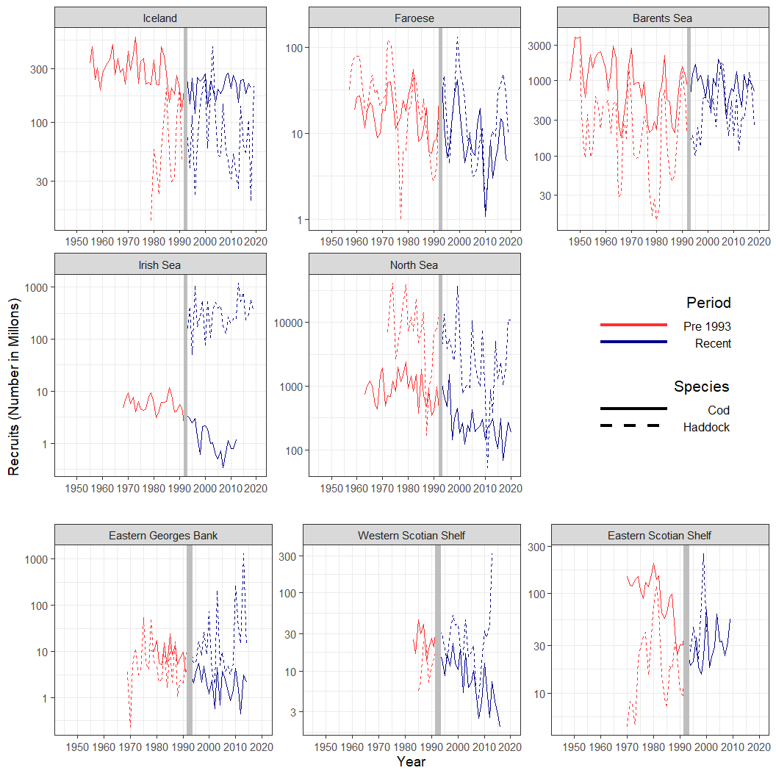

Figure 1 Recruitment (in millions) time series for 8 Atlantic Cod (solid line) and Haddock (dashed line) stocks in the Atlantic Ocean. The red line indicates data from the Pre-1993 Period, while the blue line is for the Recent Period. The vertical grey line indicates the division between the two periods. Please note that the age at recruitment varies between regions: Iceland age 2 (cod age 3 in original assessment, back calculated to age 2 assuming M=0.2 and F=0), Faroese age 1, Barents Sea age 3, Irish Sea age 1 (Haddock adjusted from age 0 by assuming m=0.2 and F0 from discards taken from the assessment report), North Sea age 1 (haddock using Number at age 1 from assessment report). The North west Atlantic stocks all recruitment age 1.

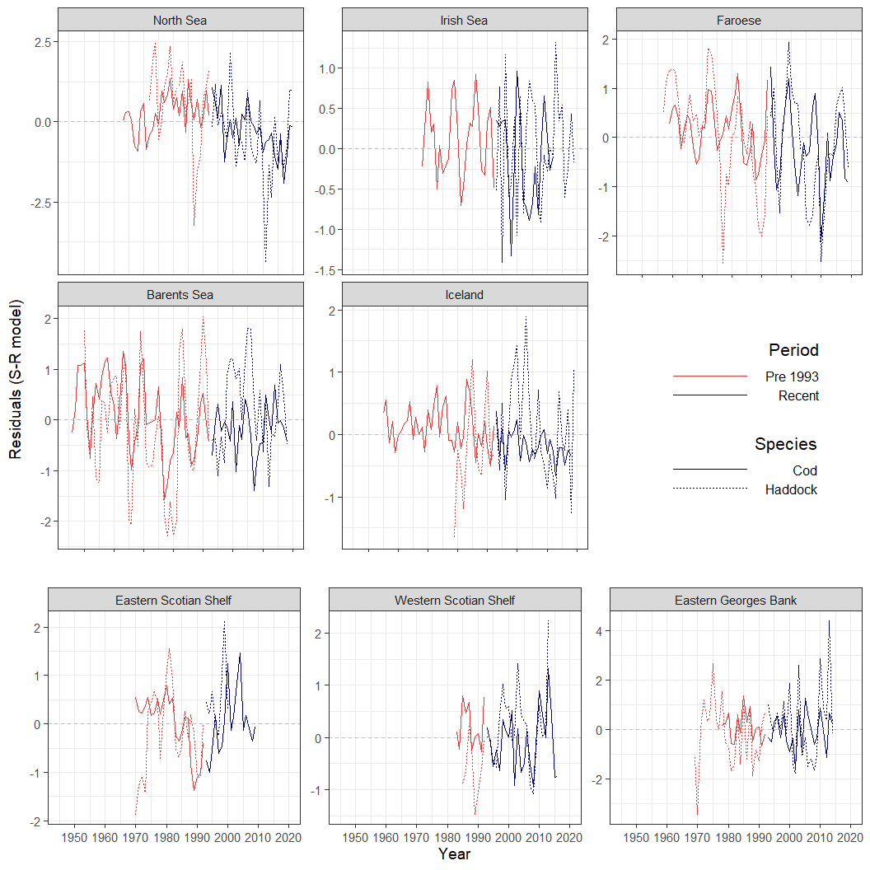

Figure 2a) Residuals from the linearized Ricker Stock recruitment model fitted to for eight Atlantic Cod (solid line) and Haddock (dashed line) stocks in the Atlantic Ocean. The red line indicates data from the Pre-1993 Period, while the blue line is for the Recent Period.

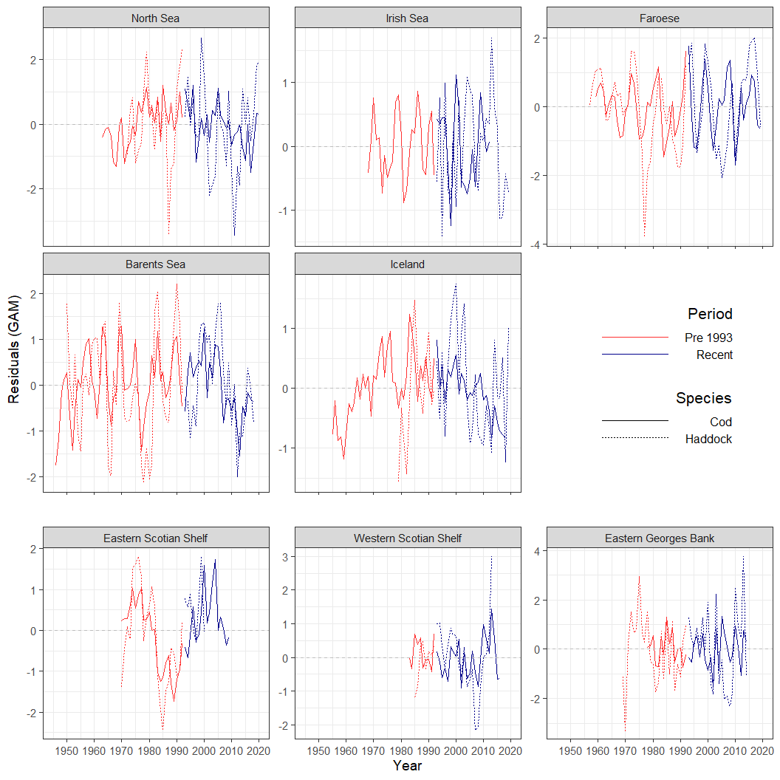

Figure 2b) Residuals from the gam model fitted to log10 recruitment for eight Atlantic Cod (solid line) and Haddock (dashed line) stocks in the Atlantic Ocean. The red line indicates data from the Pre-1993 Period, while the blue line is for the Recent Period.

0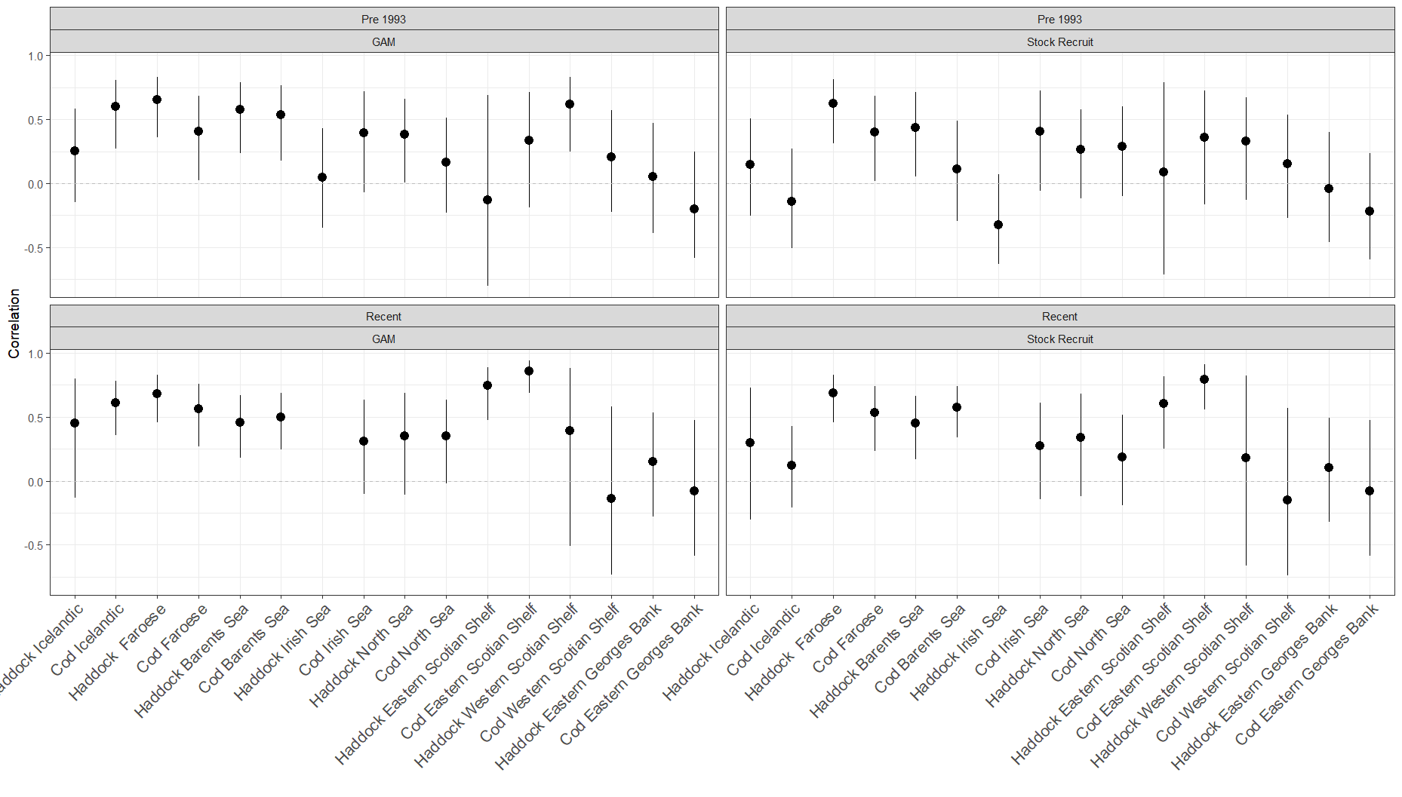

Figure 3. First order autocorrelation in recruitment residuals.

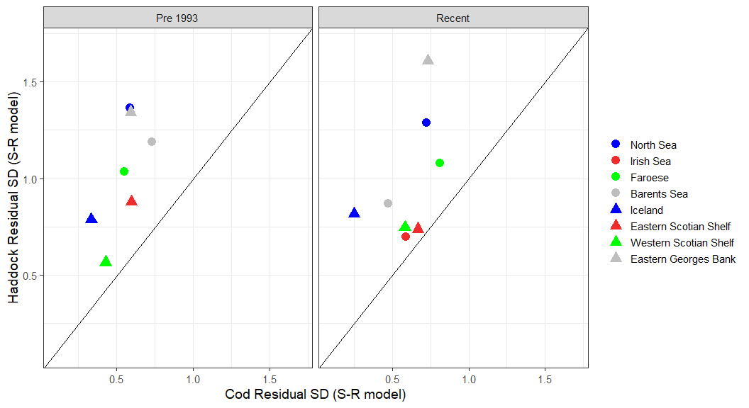

A)

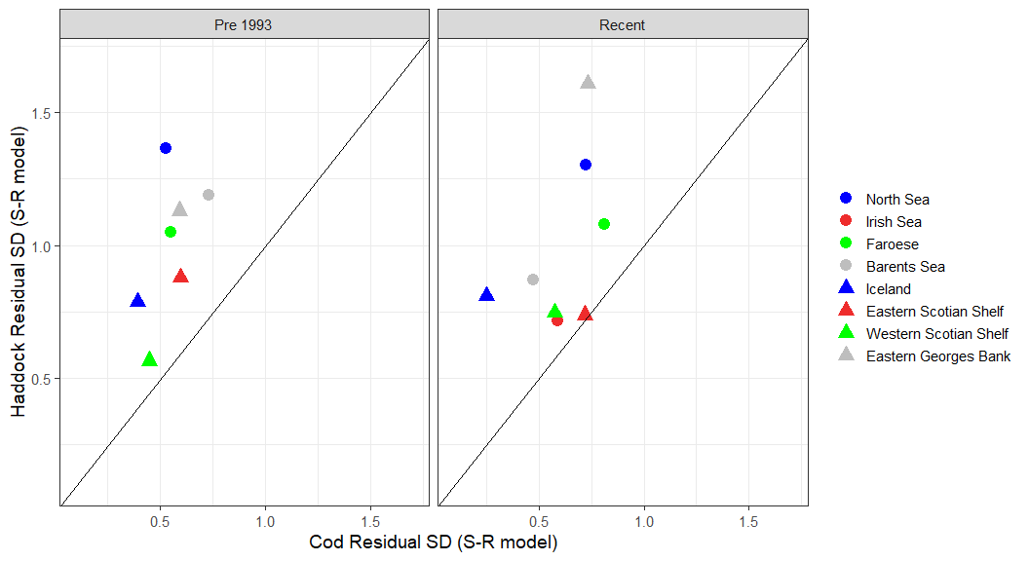

B)

*Figure 4. Standard deviation of residuals of the Ricker (upper a) and gam models (lower b) for cod (x axis) plted vs haddock (y- axis) for the recent period (right 1993 and onwards) and previous period (left) for eight regions in the North Atlantic Ocean. The Irish Sea is missing for the previous period. Axis labels in B) are incorrect – GAMs and not S-R model*

Figure 5. Cross correlation of the recruitment (log scale) time series showing the correlation coefficients with confidence limits

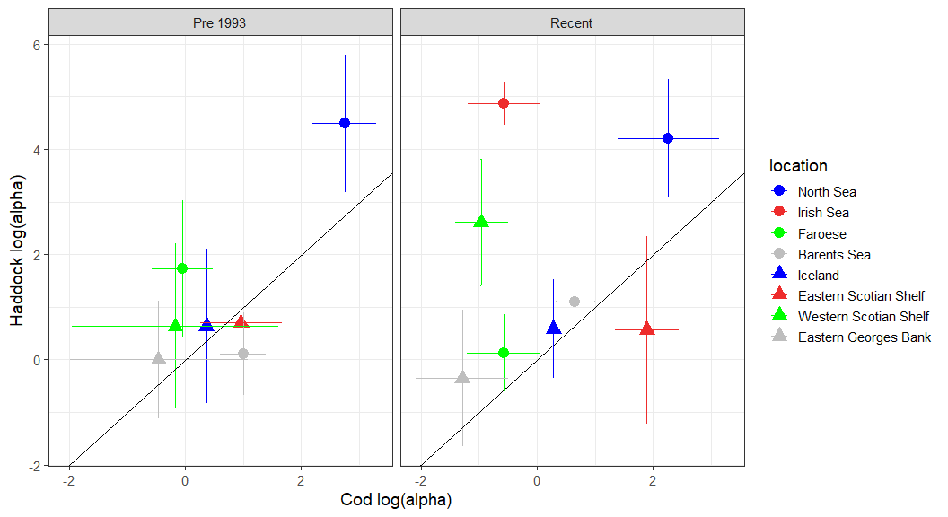

Figure 6. Estimated log(**a**) from Ricker Stock Recruitment models for each stock in the Pre 1993 and Recent period.

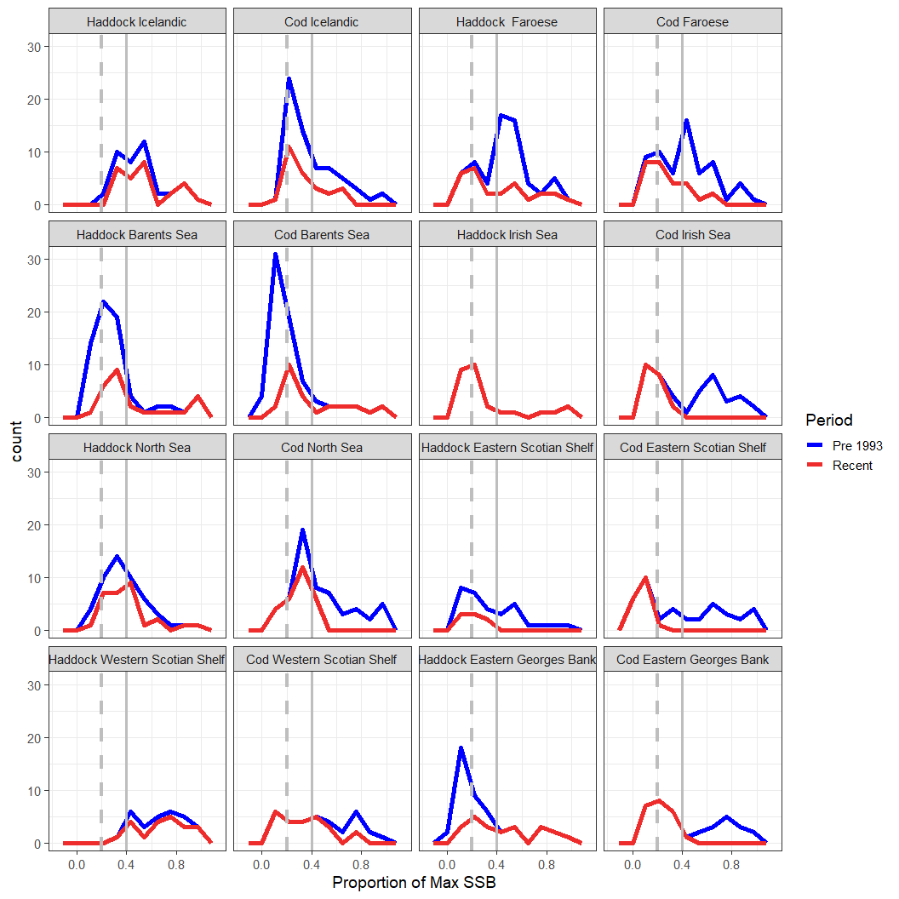

*Figure 7. Density plot of the SSB values by each period. Vertical grey dashed line is the SSB of 0.2 while the grey solid vertical line is 0.4*

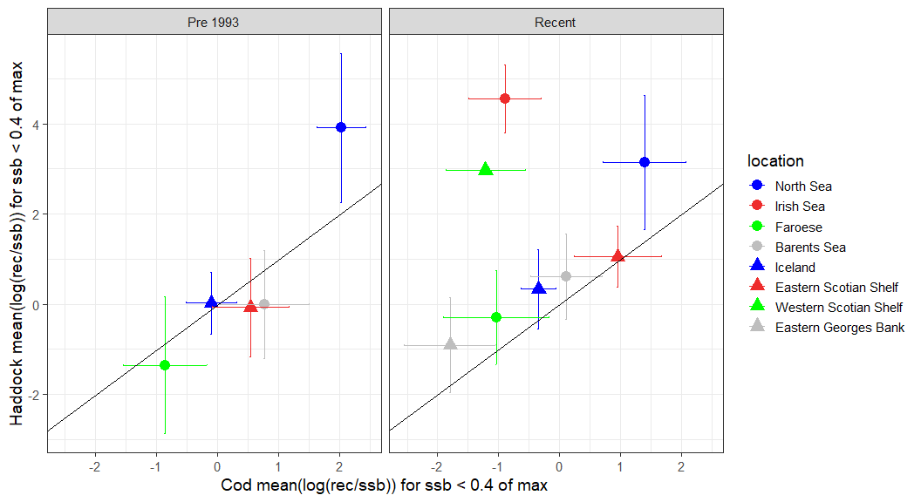

Figure 8: The mean log(Rec/SSB) when SSB is <= 0.4 of maximum ssb